**The Neuroendocrine Impact of Acute Stress on Synaptic Plasticity**

**(dos-Santos et al., 2023)**

-“Glucocorticoids act on CRH neurons to inhibit excitatory synaptic transmission via the retrograde release of the endocannabinoid 2-arachidonoylglycerol (2-AG), which suppresses presynaptic glutamate release (36) and inhibits HPA activation”

-“Glucocorticoids also rapidly alter the postsynaptic intrinsic excitability of PVN neurons via modulation of membrane potassium channels. ”

**Stress-related synaptic plasticity in the hypothalamus**

**(Bains et al., 2015)**

-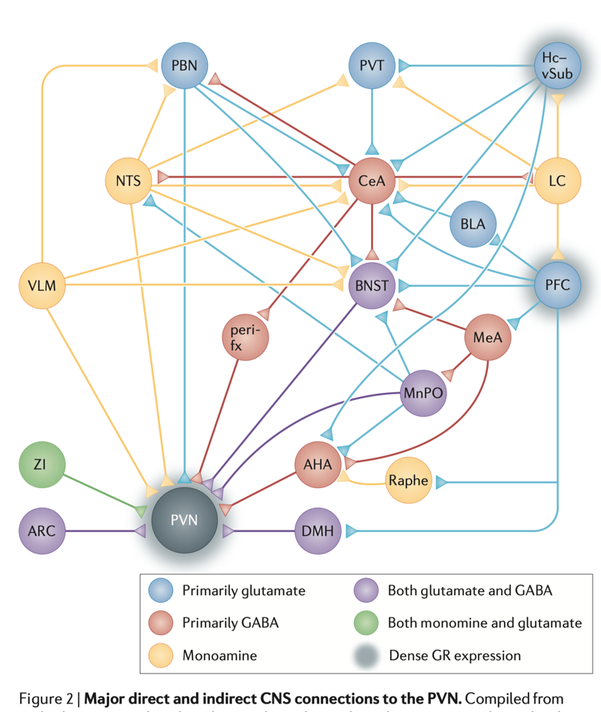

-Moreover, microinjection of glutamate into the PVN stimulates HPA-axis output, whereas administration of an ionotropic glutamate receptor antagonist before exposure to stress blunts the neuroendocrine stress response

-Endocannabinoids (eCBs) have been implicated repeatedly in the negative regulation of HPA-axis responses

-A single acute stress alters signalling at glutamatergic synapses on PNCs. This manifests as an increase in the ratio of AMPAR- to NMDAR-mediated transmission35

-Surprisingly, this is not due to an increase in signalling via AMPARs, but rather to a long-lasting decrease in NMDAR signalling35 that results from the downregulation of postsynaptic NMDARs by local release of CRH during stress.

-STP is not due to an increase in postsynaptic glutamate signalling or an increase in release probability; instead, it is due to a switch in the mode of release at glutamatergic synapses from univesicular (that is, a presynaptic action potential releases, at most, a single vesicle of glutamate) to multivesicular (that is, a presynaptic action potential can release more than one vesicle).

-These observations suggest that CRH-mediated decreases in NMDAR-dependent Ca2+ entry during stress prevent the release of a retrograde messenger that normally blocks the multivesicular release of glutamate following high levels of presynaptic activity

-There are various dendritically released factors that could be responsible for suppressing glutamate release84, but experiments have ruled out eCBs acting at CB1, opioids or adenosine35

**Synaptic regulation of the hypothalamic–pituitary–adrenal axis and its modulation by glucocorticoids and stress**

**(Levy and Tasker, 2012)**

-Glutamatergic synaptic inputs to CRH cells are suppressed by rapid glucocorticoid actions that appear to be involved in the glucocorticoid-mediated fast negative feedback of the HPA axis

-Importantly, this glucocorticoid effect was blocked by antagonists and mimicked and occluded by agonists of the cannabinoid type 1 receptor (CB1R), suggesting the involvement of the endocannabinoid system.

-We recently corroborated this with the finding that the rapid glucocorticoid effect is absent in CB1R knockout mice

-Consistent with the endocannabinoid acting as a retrograde messenger to inhibit glutamate release at glutamate synapses, the glucocorticoid effect was prevented by blockade of G protein and protein kinase activity and Ca2+ signaling specifically in the postsynaptic cell

-glucocorticoids trigger a form of endocannabinoid-mediated long-term depression of synaptic excitation

-preliminary evidence for the desensitization to the rapid glucocorticoid-induced suppression of glutamate release in brain slices from animals that had been subjected to an acute 30-min restraint stress prior to sacrifice

-This effect is likely due to the long-term depression of glutamatergic synaptic inputs by a tonic activation of presynaptic CB1 receptors via glucocorticoid-induced retrograde endocannabinoid release, since a CB1 receptor-mediated inhibitory tone was observed in glutamate inputs to parvocellular neurons from acutely stressed rats, but not from unstressed rats.

Repeated restraint stress enhances glutamatergic transmission in the paraventricular nucleus of the rat hypothalamus (<https://www.researchgate.net/publication/259200098_Repeated_restraint_stress_enhances_glutamatergic_transmission_in_the_paraventricular_nucleus_of_the_rat_hypothalamus>)

**Acute stress facilitates glutamatergic long-term potentiation in PVN magnocellular neurons through beta-adrenergic receptor/PKA cascade in vitro in rats**

**(Jin et al., 2024)**

-age and sex of wistar rats not specific

-HFS-induced NMDAR-independent LTP of PVN MNCs in acute stress rats was mediated by β-AR

-HFS-induced NMDAR-independent LTP of PVN MNCs in acute stress rats through postsynaptic PKA signaling pathway

**Sex differences in the murine HPA axis after acute and repeated restraint stress**

**(Nalepa et al., 2025)**

-Plasma CORT was increased after ARS in both males and females (p < 0.0001) compared to NS mice. Additionally, CORT levels were higher in female mice after ARS compared to male mice (p = 0.0004), while no sex differences were found in the NS condition (p = 0.9856)

-After acute stress, female mice consistently produced a larger peak CORT response compared to male mice. An enhanced acute CORT response in female rodents is in accordance with previous reports (Aoki et al., Citation2010; Iwasaki-Sekino et al., Citation2009; Weinstock et al., Citation1998) and the general perception that females are more stress-reactive than males

-no significant sex differences in plasma ACTH levels were observed, which could point to increased adrenal ACTH sensitivity in female compared to male mice.

-Despite the enhanced peak CORT response in female mice after ARS, we found no sex difference in the stress recovery period up to 1.5h post-stress, where female mice returned to baseline CORT levels similarly to male mice. This suggested a steeper increase in CORT after acute stress and a steeper decrease in CORT levels after stress.